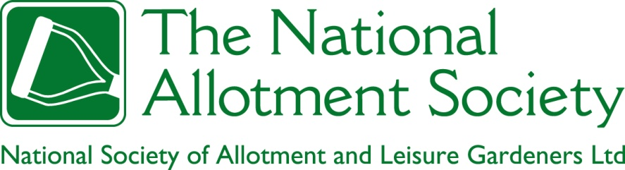

NAS Policy Document 108. Cultivation Standards

1. Tenancy agreements for allotment gardens typically include obligations to keep the plot clean, free from weeds, in a good state of fertility and cultivation, and for paths to be kept well maintained. The Society recognises that the monitoring and enforcement of these obligations is inherently subjective, and increasingly so, given the proliferation of gardening styles to be found on allotments in the UK.

2. As a minimum requirement, the Society believes that allotment gardens should be cultivated in a way that does not interfere in a material way with the enjoyment of neighbouring tenants, or that is likely to impede the ability of the allotment provider to re-let the plot at a later date. Providers may also wish to set standards for the proportion of the land put to use in the production of fruit, vegetables, flowers and the keeping of permitted livestock, and for the maintenance of residual areas.

3. The Society believes that the cultivation of allotment gardens should be subject to a regime of inspection that is timely, fair, unintrusive and appropriate to the season. It further believes that allotment garden tenants have an obligation to cooperate in such inspections, including enabling access when external visual inspection is impractical.

4. The Society believes that enforcement procedures for non-cultivation should be fair, and made known at the outset to any tenant against whom action is proposed. Such procedures should include clear documentation of faults, an early opportunity to declare any mitigating circumstances (which should be treated in confidence), and deadlines for rectification that allow reasonable time for the tenant to take action, bearing in mind the time of year. Courses of action should offer alternatives to termination wherever possible, including the opportunity to cultivate a smaller plot, especially when there is no prior history of non-cultivation. An independent appeals procedure should also be in place. Where faults are left unrectified and all alternatives refused, however, the Society recognises the right of the allotment provider to terminate the tenancy in accordance with the terms set out in the tenancy agreement and relevant legislation.

